Highlights of ‘Symposium on Small-scale Aquaculture for Increasing Resilience of Rural Livelihoods in Nepal’

5-6 February 2009
Kathmandu, Nepal

The Symposium on ‘Small-scale aquaculture for increasing resilience of rural livelihoods in Nepal’ was held on 5-6 February 2009 in Kathmandu. Mr. Pushpa Kamal Dahal ‘Prachanda’, Prime Minister of Nepal, graced the event with his presence as the Chief Guest at the inaugural ceremony. In his inaugural speech, Prime Minister Dahal, recognizing the potential role of small-scale aquaculture for improving livelihoods of a large number of rural communities, emphasized the need for its development as a ‘campaign’ in order to reach out to the poor across the country, through collaboration among various national and international research and development partners. He underlined the country’s need for becoming self-sufficient in fish production. The Prime Minister further laid great stress on embracing resource-poor, women, and marginalized communities and developing them as entrepreneurs by organizing them through fish production and marketing cooperatives. The inaugural session was chaired by Dr. Guna Nidhi Sharma, Vice-Chairman of the National Planning Commission of Nepal. The highlights of the symposium were widely covered by local televisions, radios and newspapers.
Over 100 professionals from Nepal, India, Bangladesh, Thailand, China, Malaysia and Denmark participated in the symposium. A total of 39 presentations (26 oral and 13 posters) on small-scale aquaculture research and development were made. The WorldFish team ⎯ from its Headquarters Penang and South Asia Regional Office ⎯ made five presentations.
The papers and posters presented at the symposium clearly demonstrated the success of a number of pilot projects on small-scale aquaculture development undertaken by N/GOs sectors in Nepal in the recent years. They reflected potential for improving livelihoods of rural communities through harnessing the aquaculture development potential of the country. Key focus areas and recommendations for small-scale aquaculture development in Nepal were drawn from a plenary session at the end of the symposium.
1. Policy and institutional development: A small-scale aquaculture development program should be launched as a national campaign under a special program. An inter-sectoral committee including key stakeholders (for example, National Aquaculture and Fisheries Development Board) should be formed to develop strategies, plan and facilitate implementation of aquaculture research, education and development programs.
2. Production and marketing models: Although small-scale aquaculture systems are largely aimed at meeting household food and nutrition security, linking them with market and up-scaling of their production systems (intensification as well as expansion) is vital to improving livelihoods while contributing towards meeting national fish demand. Organizing small-scale producers in production and marketing groups and cooperatives is likely to be an effective production and marketing model for aquaculture development in Nepal.
An effective mechanism should also be established for collection and maintenance of a reliable database on production-consumption, imports – exports, and market studies.
3. Target beneficiaries: The focus of aquaculture development program in Nepal should be aimed at improving the resilience of livelihoods of small-scale farmers with access to aquatic resources. These endeavors should put women, resource-poor and marginalized communities at the centre of development.
4. Inputs and services: Provision of quality fish seed and financial services are key to the success of small-scale aquaculture development in Nepal. Utilization of on-farm resources as pond inputs would help minimize production costs but introduction of low-cost inputs from off-farm sources (for example, green water technologies) would be needed to increase production with just a modest increases in the cost.

The technical committee is working on finalizing the symposium proceedings which will include full papers presented, and is expected to be produced by June 2009.

This symposium was jointly organized by a total of nine national and internal organizations, namely Institute of Agriculture and Animal Science (IAAS), Tribhuvan University, Nepal; Nepal Agriculture Research Council (NARC), Nepal; Directorate of Fisheries Development, Department of Agriculture, Nepal; Nepal Fisheries Society (NeFiS); Asian Institute of Technology (AIT), Thailand; The WorldFish Center, Penang, Malaysia; Plan Nepal; Canadian Cooperation office/CIDA Nepal; and Nepal Academy of Science and Technology (NAST).

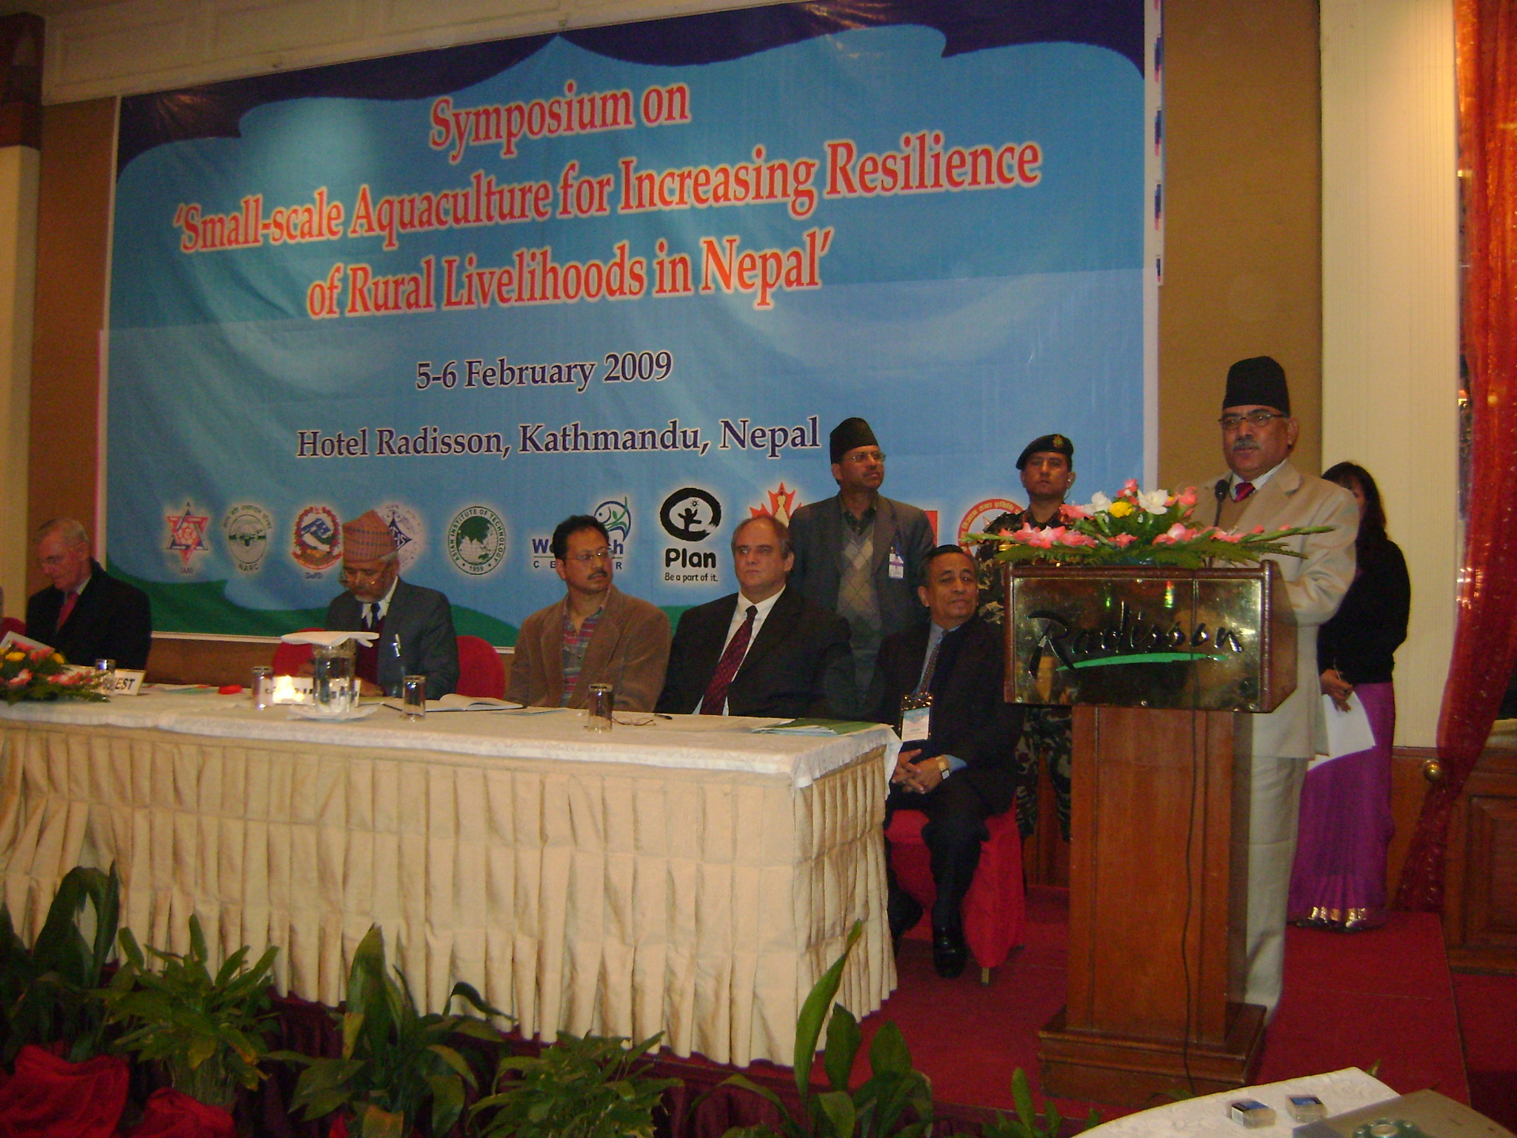
Photo 1: Prime Minister of Nepal Mr. Pushpa Kamal Dahal ‘Prachanda’ delivering inaugural speech

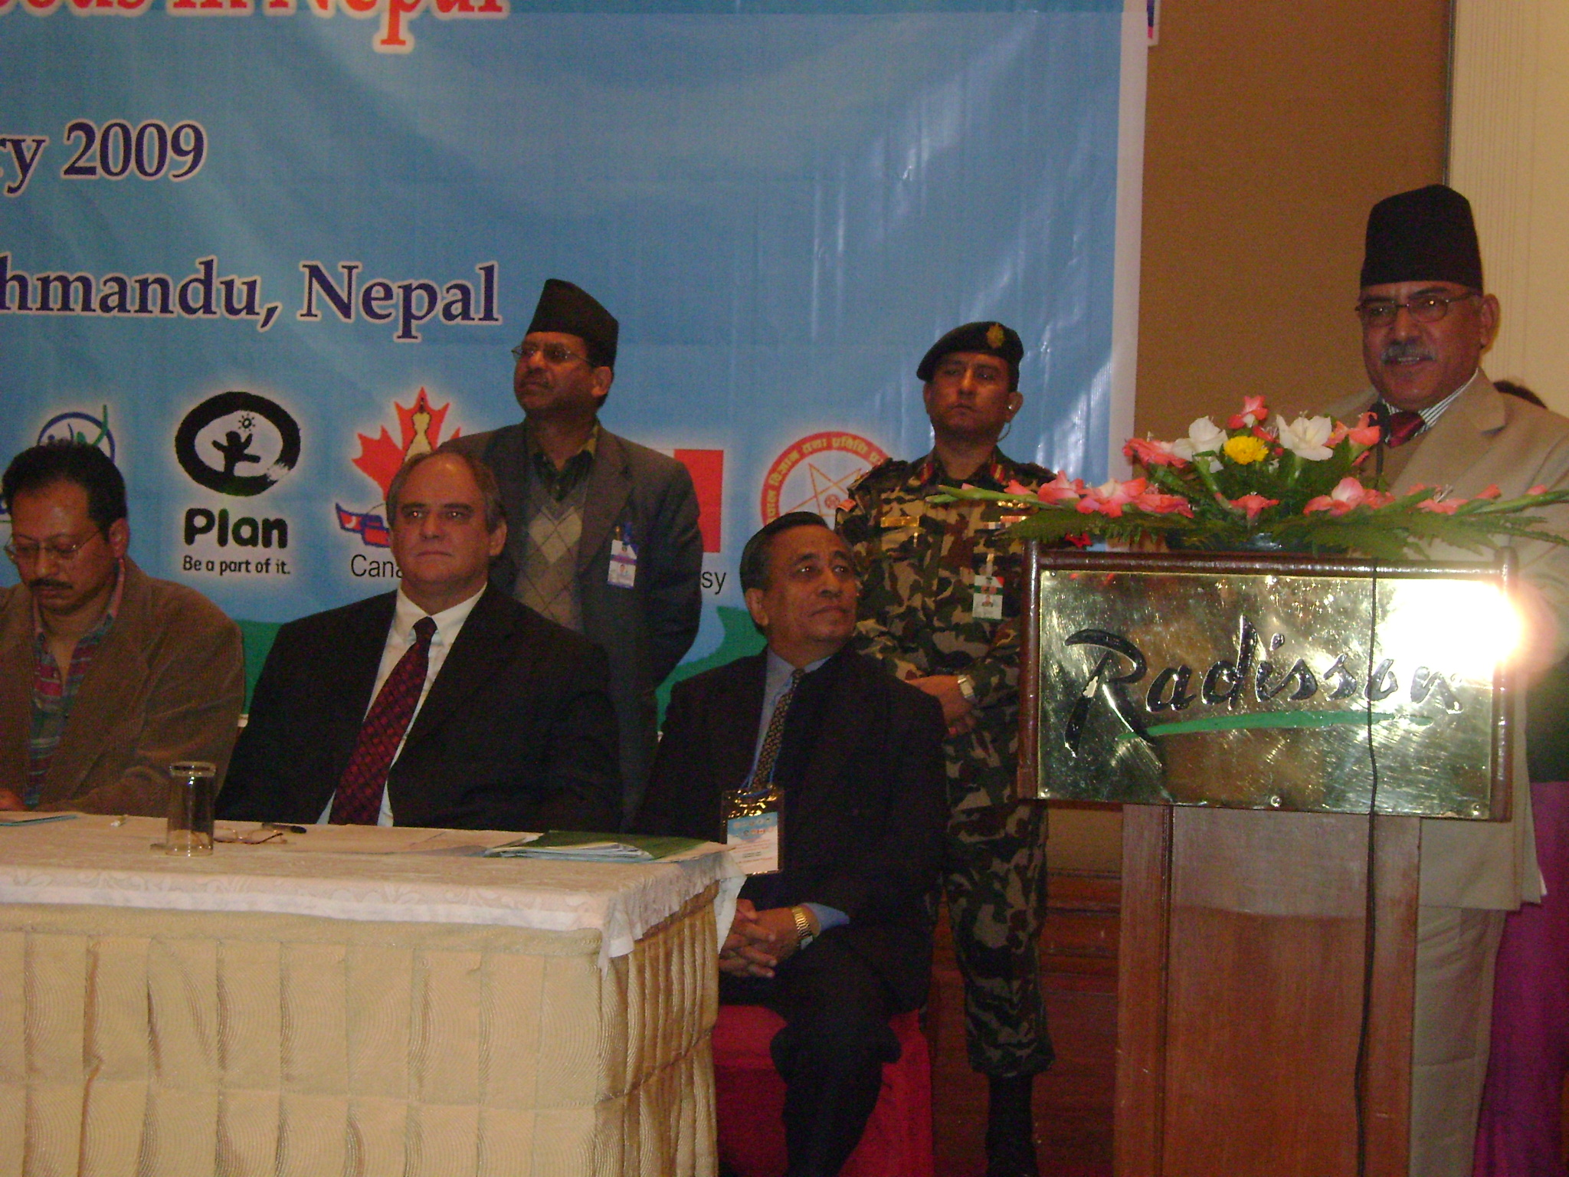
Photo 2: Prime Minister of Nepal Mr. Pushpa Kamal Dahal ‘ Prachanda’ delivering inaugural speech
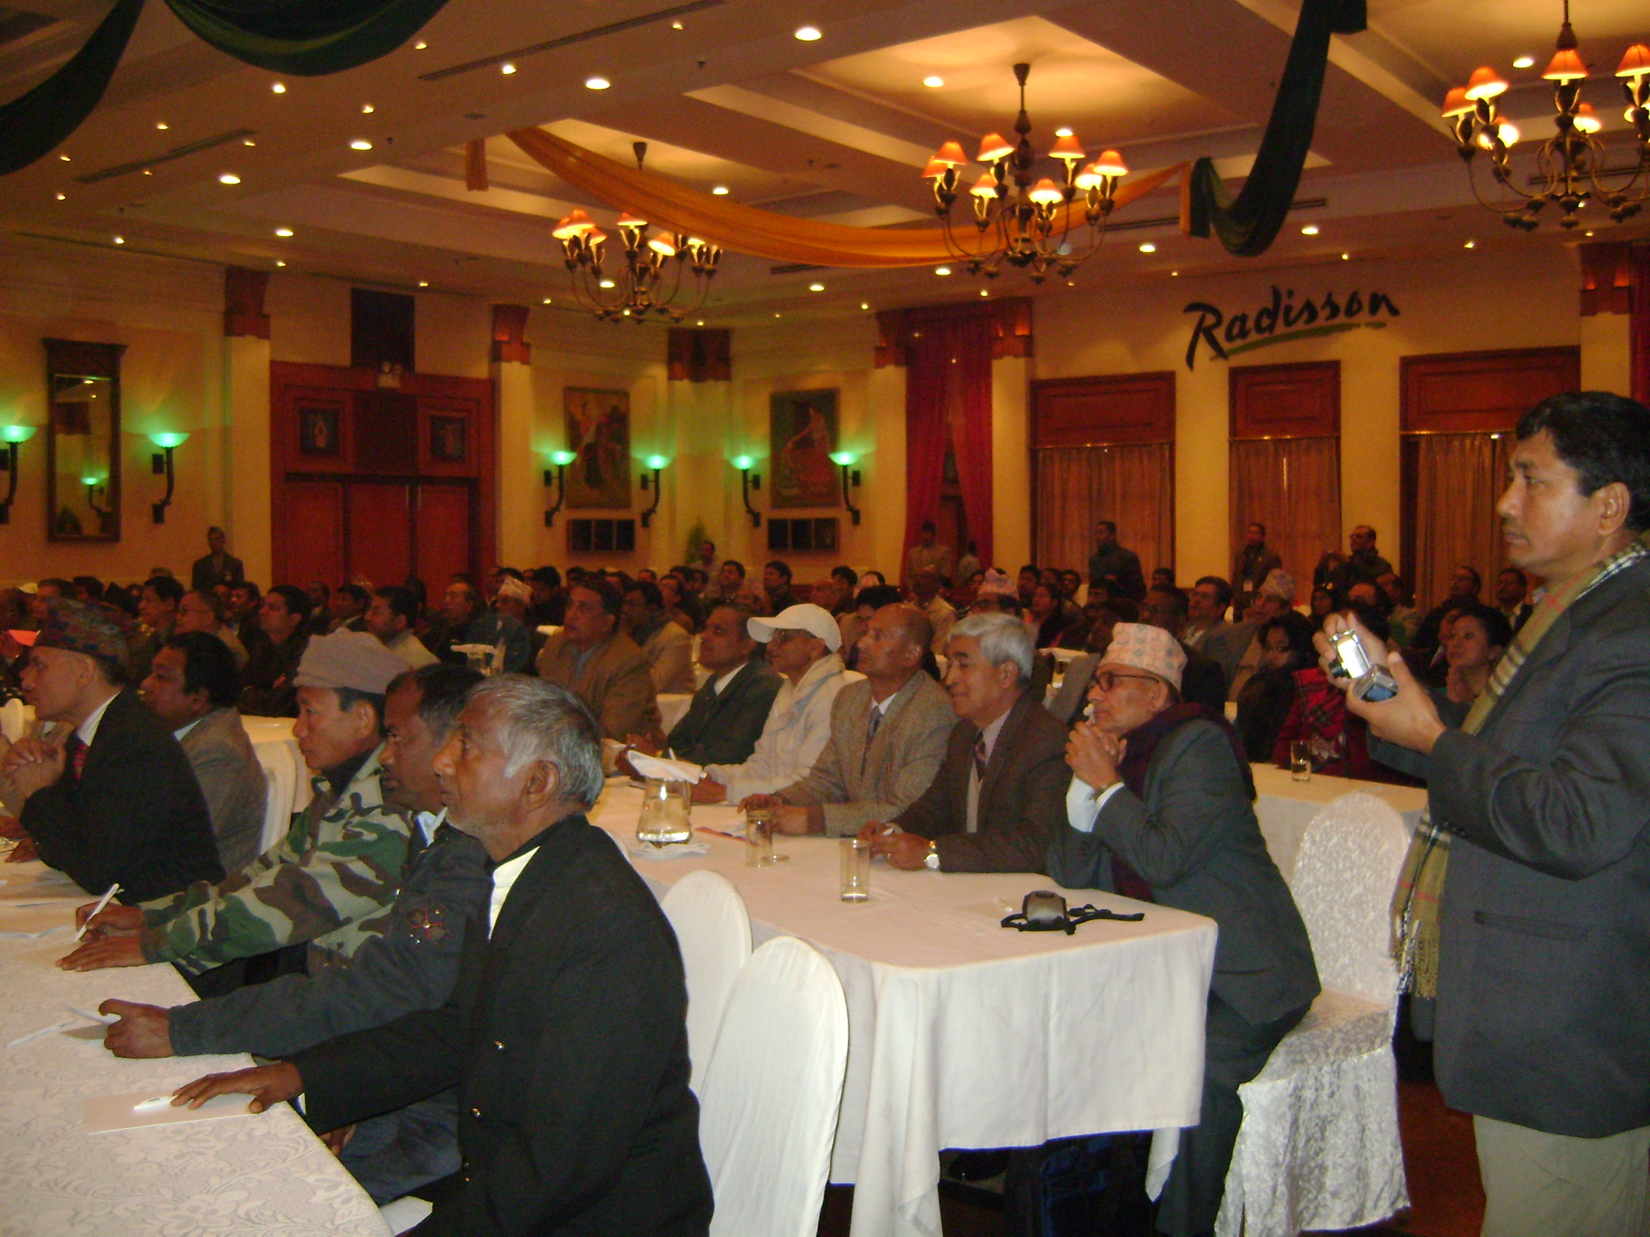

Photo 3: Inaugural session participants

